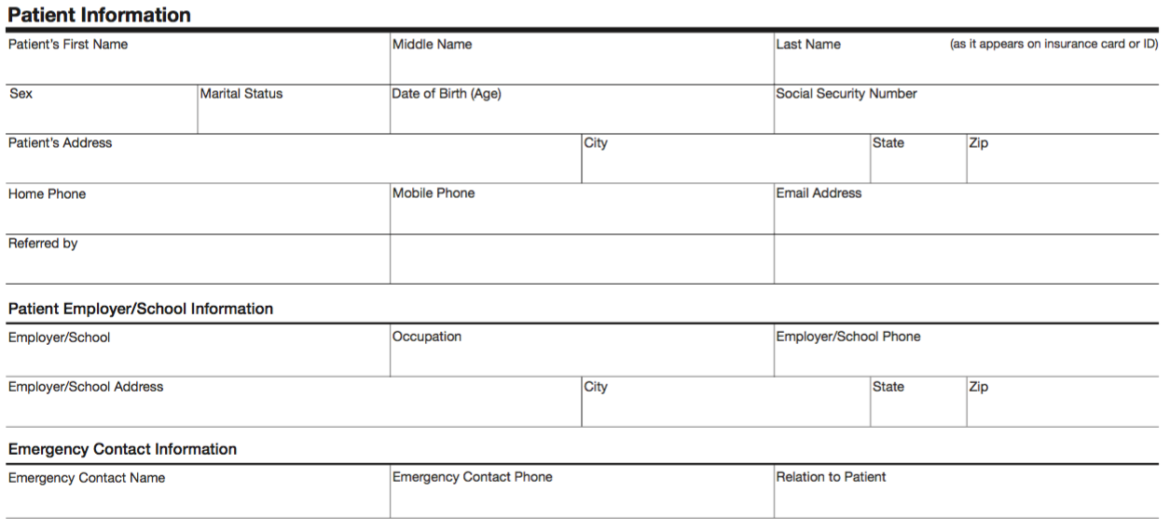

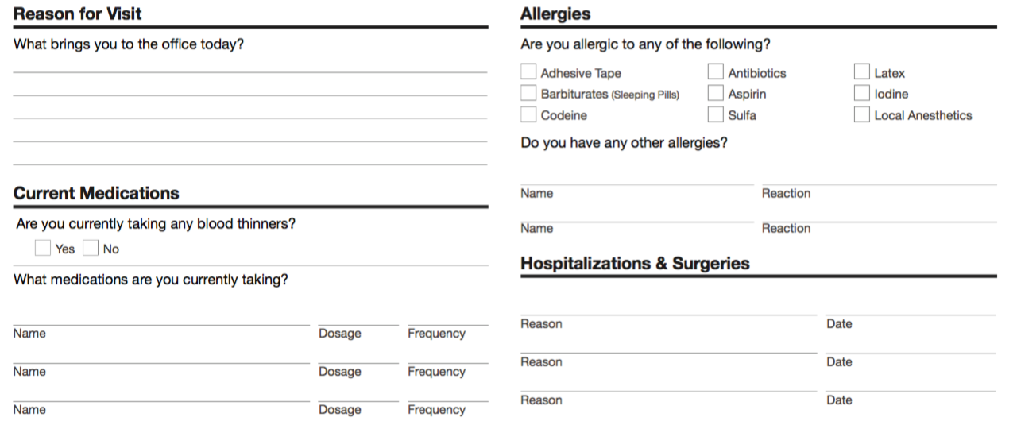

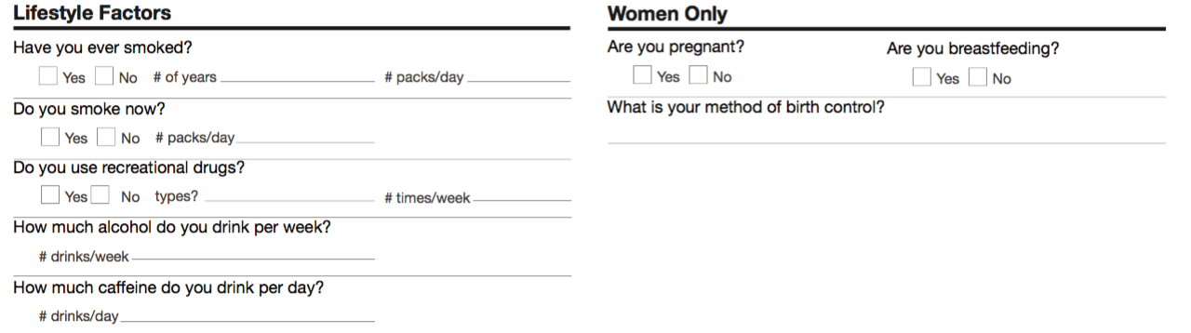

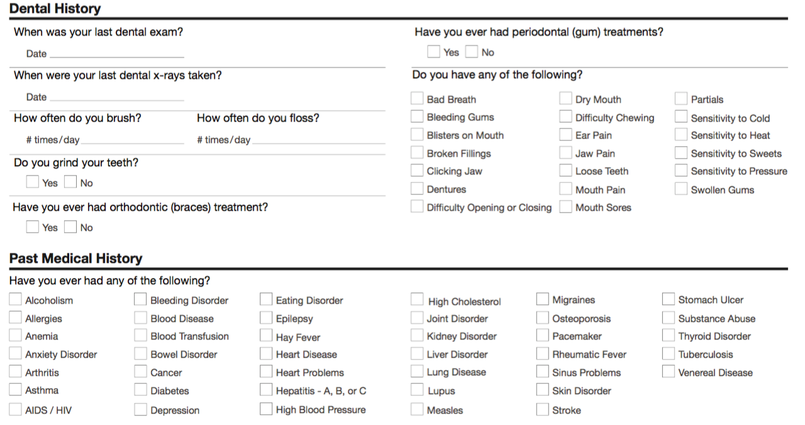

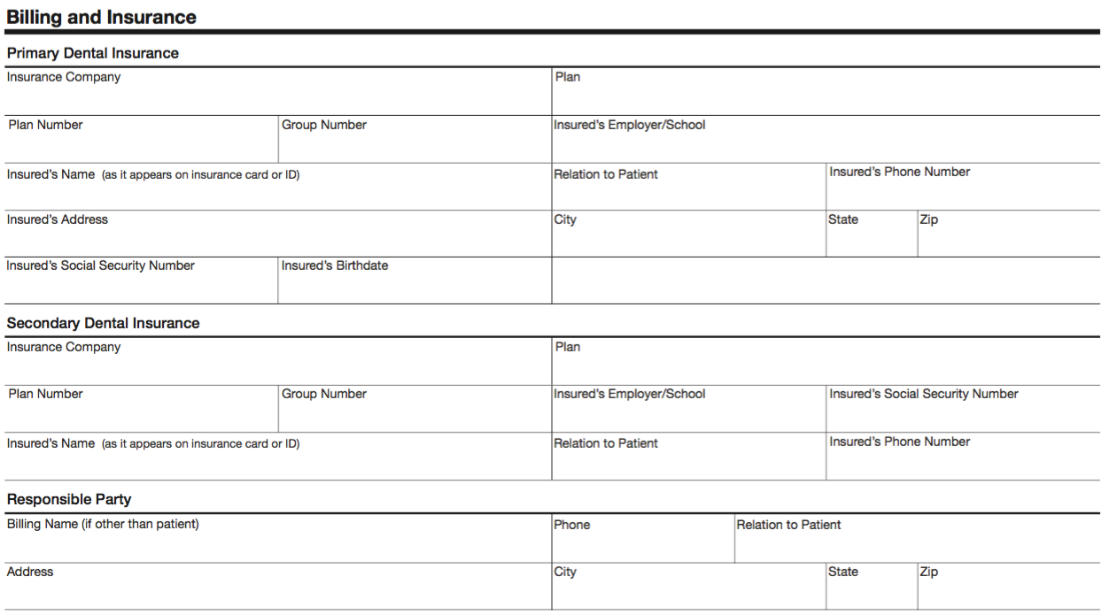

Appointment Cancellation Policy
We strive to render excellent dental care to you and the rest of our patients. We know your time is valuable, so in an attempt to be consistent with this, we schedule exclusive appointment times that are reserved only for you. We do not double book appointments which means that time has been set aside for you and cannot be used to treat another patient.
We require that patients give our office 48 hours notice in the event that they need to reschedule an appointment. This allows for other patients to be scheduled into that appointment. If you miss an appointment without contacting our office within the required time, this is considered a missed appointment and a fee of $100.00 will be charged to you. This fee cannot be billed to your insurance company and will be your direct responsibility. No future appointments can be scheduled nor can records be transferred with out the payment of this fee.
Additionally, if a patient is more than 15 minutes late without prior notice for a scheduled appointment, we will consider this a missed appointment and a $100.00 fee will be charged. We strive to always be on time for our patients and therefore if you are late to your appointment we may need to reschedule you so we can stay on time for our other patients.
If you have any questions regarding this policy, please let our staff know and we will be glad to clarify any questions you have.
I have read and understand the Appointment Cancellation Policy of the practice and I agree to be bound by its terms. I also understand and agree that such terms may be amended from time-to-time by the practice.
I, ___________________________ (print name), agree to the AVPeriodontics Appointment Cancellation Policy.
_____________________________ (Signature) _______________________ (Date)

NOTICE OF PRIVACY PRACTICES

THIS NOTICE DESCRIBES HOW HEALTH INFORMATION ABOUT YOU MAY BE USED AND DISCLOSED AND HOW YOU CAN GET ACCESS TO THIS INFORMATION

PLEASE REVIEW IT CAREFULLY
THE PRIVACY OF YOUR HEALTH INFORMATION IS IMPORTANT TO US

USES AND DISCLOSURES OF HEALTH INFORMATION
We use and disclose health information about you for treatment, payment, and healthcare operations. For example:

Treatment: We may use or disclose your health information to a physician or other healthcare provider providing treatment to you, or to family and friends you approve.

Payment: We may use and disclose your health information to obtain payment for services we provide to you.

Healthcare Operations: We may use and disclose your health information in connection with our healthcare operations. Healthcare operations include quality assessment and improvement activities, reviewing the competence or qualifications of healthcare professionals, evaluating practitioner and provider performance, conducting training programs, accreditation, certification, licensing or credentialing activities.

Your Authorization :In addition to our use of your health information for treatment, payment or healthcare operations, you may give us written authorization to use your health information or to disclose it to anyone for any purpose. You also have the right to request restrictions on disclosure of PHI (Personal Health Information),or alternative means of communication to ensure privacy.

Marketing Health-Related Services: We will not use your health information for marketing communications without your written authorization.

Required by Law: We may use or disclose your health information when we are required to do so by law or national security activities.

Abuse or Neglect: We may disclose your health information to appropriate authorities when we suspect abuse or neglect.

Appointment Reminders: We may use or disclose your health information to provide you with appointment reminders
(Such as voicemail messages, postcards, or letters).

PATIENT RIGHTS

Access: You have the right to look at or get copies of your health information with limited exceptions. If you request copies, we will charge you a reasonable fee to locate and copy your information, and postage if you want the copies mailed to you.

Amendment: You have the right to request that we amend your health information.

QUESTIONS AND COMPLAINTS
If you want more information about our privacy practices or have questions or concerns, please contact us.

If you are concerned that we may have violated your privacy rights, or you disagree with a decision we made about access to your health information or in response to a request you made to amend or restrict the use or disclosure of your health information or to have us communicate with you by alternative means or at alternative locations, you may complain to us using the contact information listed at the end of this Notice. You also may submit a written complaint to the U.S. Department of Health and Human Services. We will provide you with the address to file your complaint with the U.S. Department of Health and Human Services upon request.

We support your right to the privacy of your health information. We will not retaliate in any way if you choose to file a complaint with us with the U.S. Department of Health and Human Services. A Privacy/Contact Officer has been designated for this office. The Privacy Officer can be contacted by simply contacting the office and asking to speak to the Office Manager who serves as the Privacy Officer.

PATIENT ACKNOWLEDGEMENT OF THE NOTICE OF PRIVACY PRACTICES
AND CONSENT FOR USE AND DISCLOSURE OF PERSONAL HEALTH INFORMATION

Print Patient’s Name Date

I,_____________________________________, acknowledge that I
(Signature of Patient or Parent or Legal Guardian) Have either received a copy of this office’s NOTICE OF PRIVACY PRACTICES or that this office’s NOTICE OF PRIVACY PRACTICES was made available to me to receive.

I, , consent to the use and disclosure of
(Signature of Patient or Parent or Legal Guardian) my personal health information by your office for Treatment, Billing / Payment and Health care Operations as outlined in the NOTICE OF PRIVACY PRACTICES.

